**Attribute exploration of German credit dataset**

1.List of attributes and their types

* Checking_status-Normal
* Duration – Numeric
* Credit_history – Nominal
* Purpose – Nominal
* Credit_amount – Numeric
* Serving_status – Nominal
* Employment – Nominal
* Istallment_commitment – Numeric
* Personal_status – Nominal
* Other_parties – Nominal
* Residence_since – Numeric
* Property_magnitude – Nominal
* Age – Numeric
* Other_payment_plans – Nominal
* Housing – Nominal
* Exizting_credits – Numeric
* Job – Nominal
* Num_dependents – Numeric
* Own_telephone – Nominal
* Foreign_worker – Nominal
* Class – Nominal

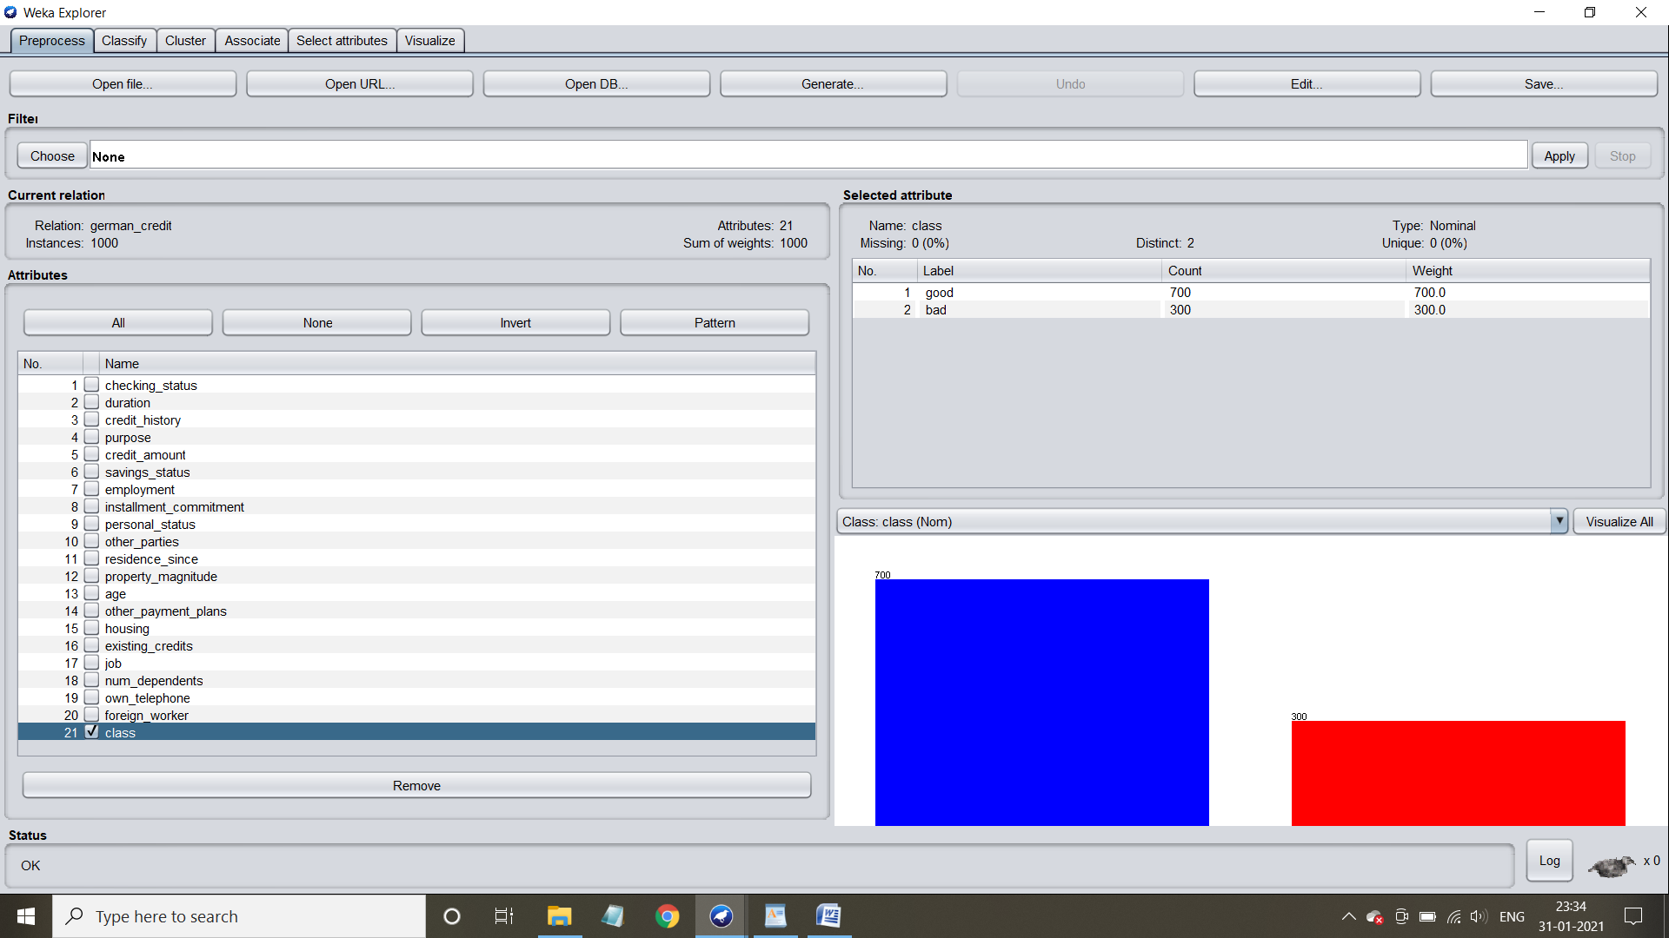

2. Number of attributes in the data set:21

and number of records/instances in the data set:1000



3. Class attribute in the data set:class

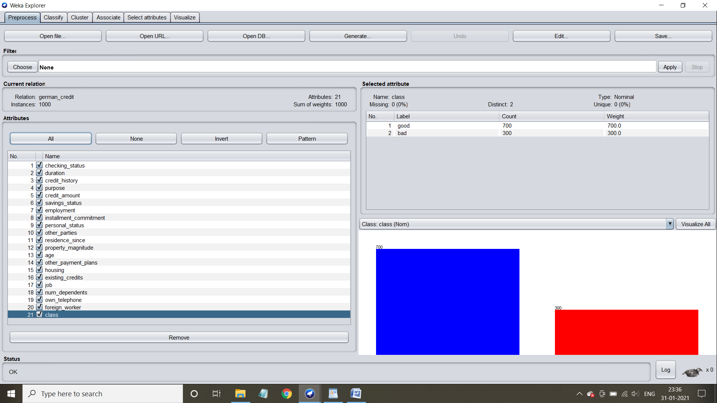

4. Number of attributes of each class:

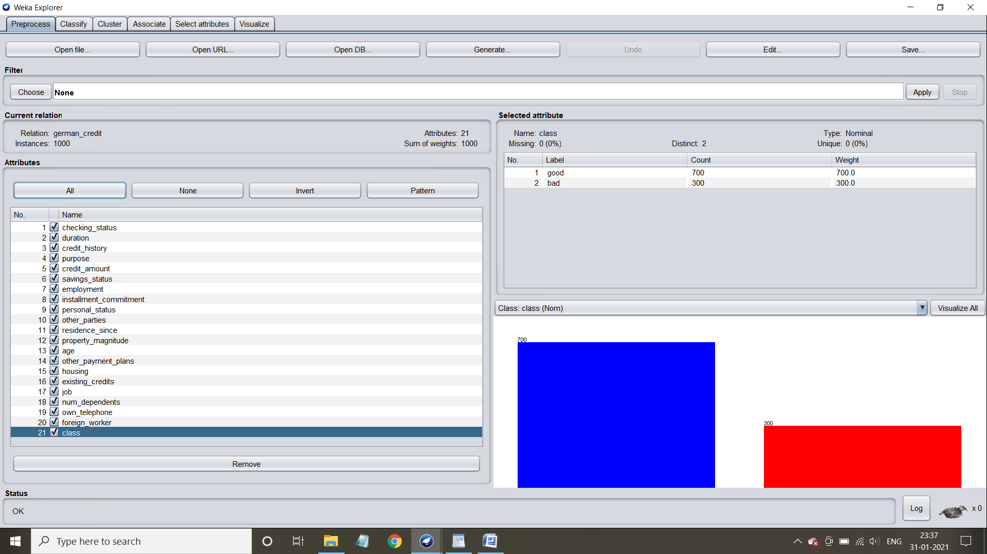

5. Graphical representation of all attributes against class attribute:

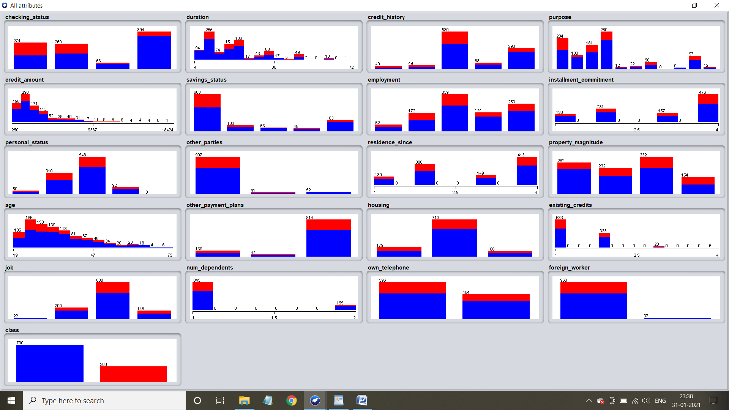

**Attribute exploration of IRIS data set**

1. List of attributes and their types

* Sepal length – Numeric
* Sepal width – Numeric
* Petal length – Numeric
* Petal width – Numeric
* Class – Nominal

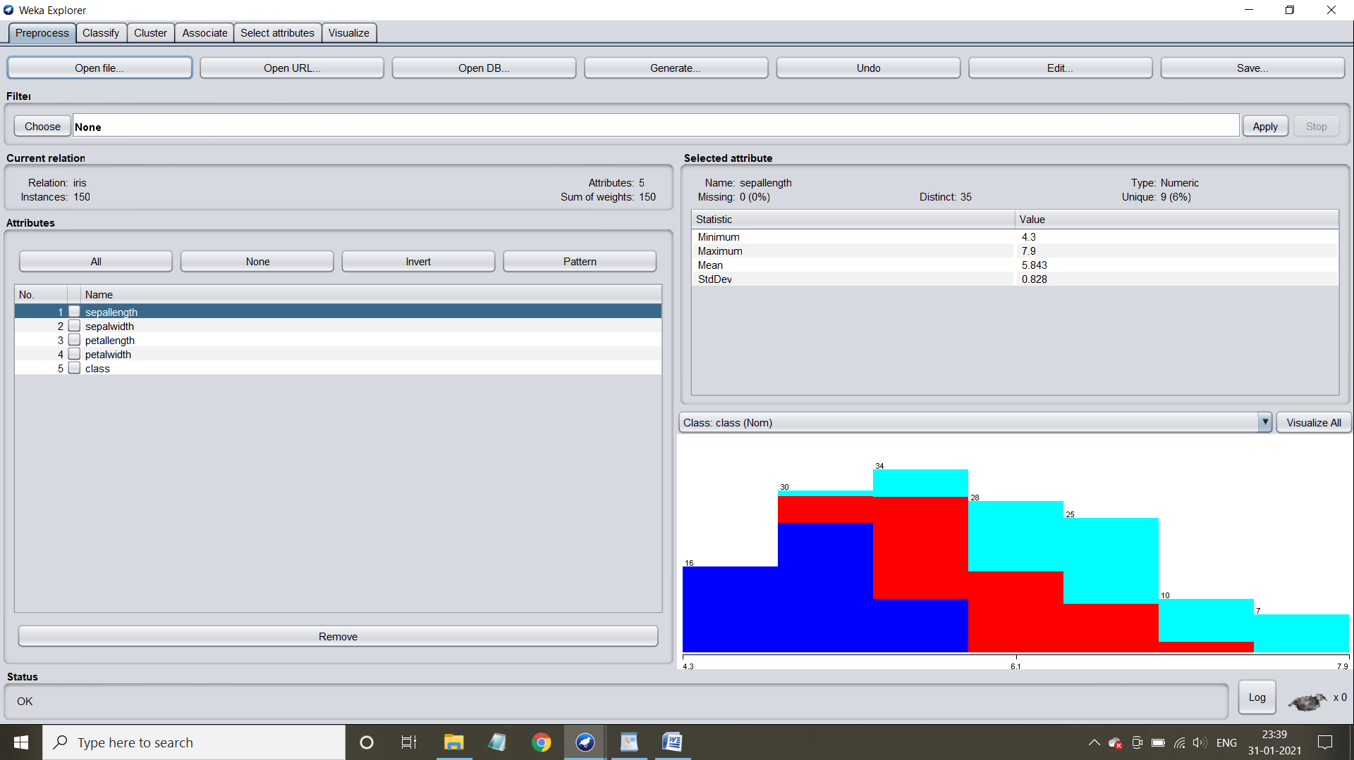

2. Number of attributes in the data set: 5

Number of records in the data set:150



3. Class attribute in the data set: class

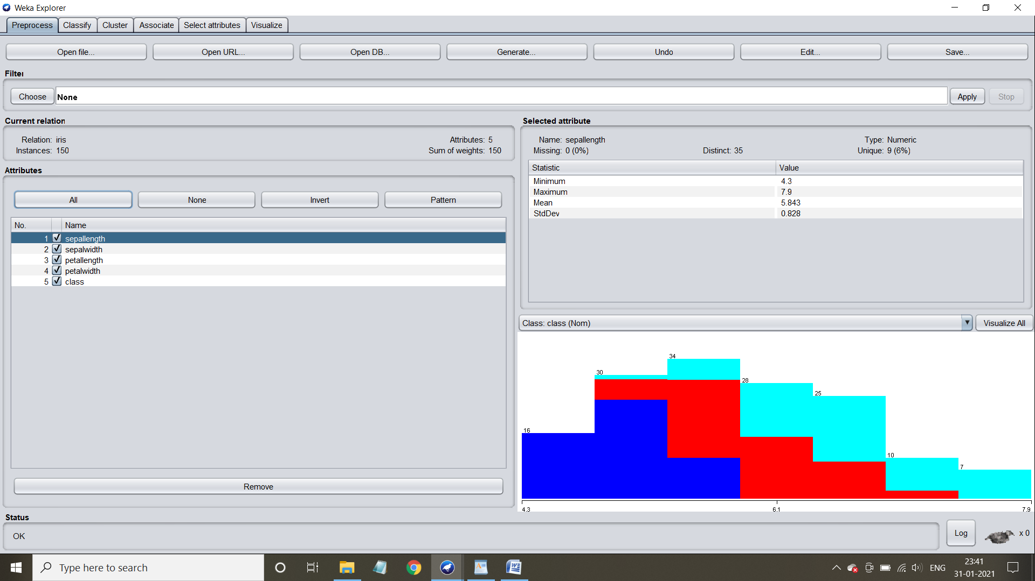

4. Number of records for each class:

* Iris-setosa – 50
* Iris-versicolor – 50
* Iris-verginica – 50

5. Graphical representation of all attributes against class attribute

